

A bit longer than 40 words…

A wonderfully eargrabbing Bush Poet and “stretcher of the truth” extraordinaire, Graeme’s performances are renowned for their vibrancy, humour and heartfelt emotion.
In the true larrikin style his reciting covers everything from the silly to the serious, Traditional to Contemporary.
Since 1995 he’s received over 56 commendations for his spoken and written work and has been included in 16 Anthologies of Australian Poetry.
He has released 2 books, 2 cassettes and 1 CD.

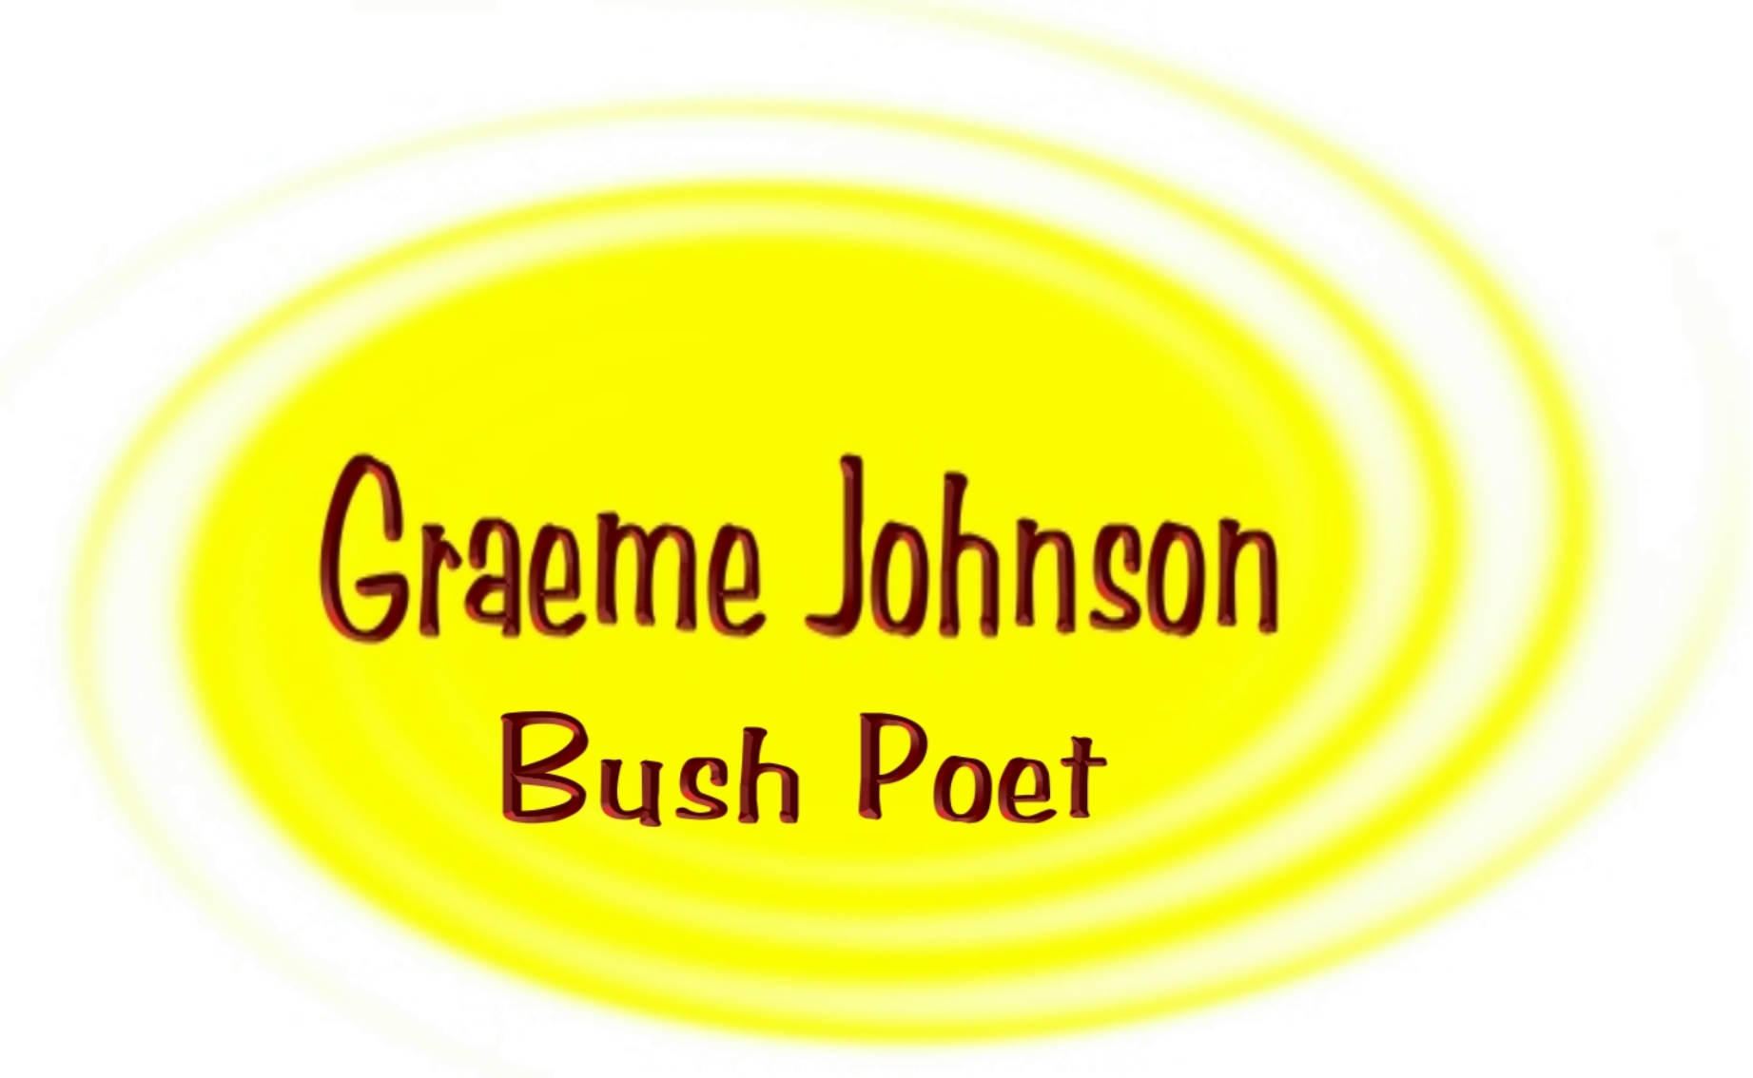
1133 Victoria Road, West Ryde, NSW, 2114
E-mail: The RhymerfromRyde@bigpond.com
(02) 9874 7653 0419 415137

